Problemy s releasem aplikaci z TFS:

**PullRequest 172**  problem s databazi, nejde zbuildit.

**Coding**

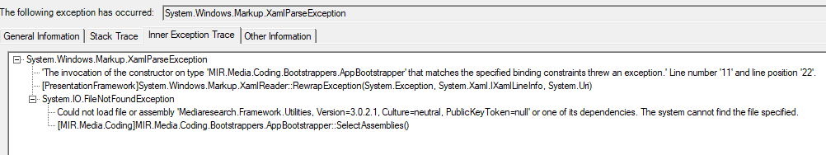

**Scanning**

Porovnaval jsem ShellProperties s jinym softem. Zkusi jsem zmenit Platform target na ANY CPU ale nepomohlo.

* Activation of \\bgfs\data\Software\AdIntelTFS\MIR.PrintStorage.Scanning2.ClickOnce\BG\Test\Scanning2_BG_Test.application resulted in exception. Following failure messages were detected:

+ Exception reading manifest from file://bgfs/data/Software/AdIntelTFS/MIR.PrintStorage.Scanning2.ClickOnce/BG/Test/Scanning2_BG_Test.application: the manifest may not be valid or the file could not be opened.

+ Deployment manifest is not semantically valid.

+ Application reference identity processor architecture, msil, does not match the processor architecture of the deployment: x86.

**Reseni:** [‎16.‎01.‎2019 10:22]  Filip Čálek:

u deploye se musi definovat -p x86

hmhm

mrkni na deploy batku skenovadla a uvidis to tam

to jeste musime na TFS dodelat

**SimLog** na cechach nefunguje ale ani nemusi

**TvLog**.**Generator**

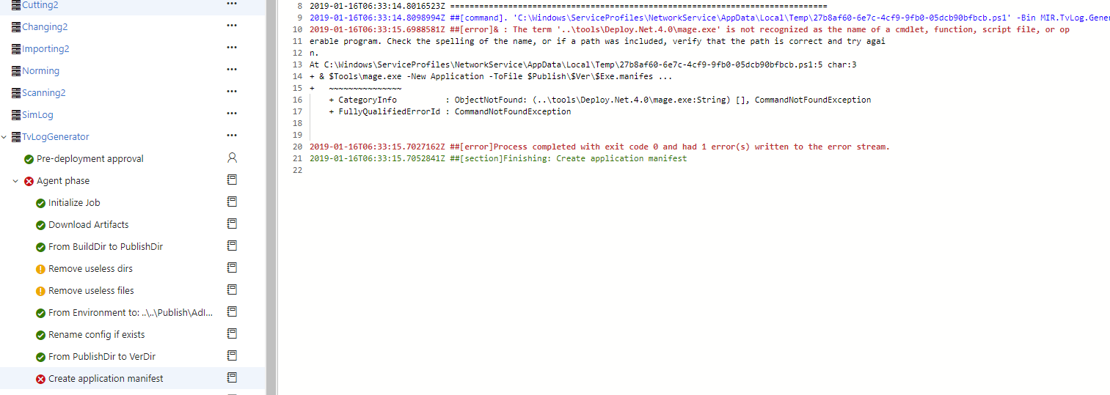

**ReprocessingGUI** prilis dlouhy nazev.

